COLLEGE OF COMPUTER STUDIES AND MULTIMEDIA ARTS

IT0049
(WEB SYSTEM TECHNOLOGIES)

TECHNICAL FORMATIVE ASSESSMENT
4

WHO'S ALLOWED IN? SESSIONS AND AUTHENTICATION

Student Name / Group Name: | Johfreeh P. Fajardo
Members (if Group):
  Name | Role
Section:
Professor:

PROGRAM OUTCOME/S (PO) ADDRESSED BY THE LABORATORY EXERCISE
- Design, implement and evaluate computer-based systems or applications to meet desired needs and requirements. [PO: C]

COURSE LEARNING OUTCOME/S (CLO) ADDRESSED BY THE LABORATORY EXERCISE
- Apply advanced web development principles in creating, debugging, validating, and securing database-backed web applications. [CLO: 2]

INTENDED LEARNING OUTCOME/S (ILO) OF THE LABORATORY EXERCISE
At the end of this exercise, students must be able to:
- Store and retrieve session data.
- Build a login form that verifies a hashed password.
- Protect pages using a CodeIgniter Filter.
- Implement a logout workflow that destroys the session.

BACKGROUND INFORMATION
So far, anyone with the URL could reach every page of the POS application. This activity adds a login requirement so that only a verified staff member can manage customer and user records. CodeIgniter Filters intercept a request before it reaches the controller, making them the right tool for enforcing this kind of access rule across many routes at once.

GRADING SYSTEM / RUBRIC
CRITERIA | Description
Functionality & Requirements Completeness (40 points max) | All required pages and features are present and work as specified in the activity instructions.
Code Structure & Organization (25 points max) | Controllers, models, and views are separated correctly and follow the framework's conventions; code is readable and sensibly named.
Authentication & Session Security (20 points max) | Passwords are hashed and verified correctly, the session correctly tracks login state, and the filter reliably blocks access to protected pages for users who are not logged in.
Documentation & Submission Quality (15 points max) | The GitHub repository is organized and complete, the README explains how to set up and run the project, and the hosted link is live and matches the submitted code.

LABORATORY ACTIVITY
Add authentication to the POS application from TFA3 so that only a logged-in user can manage customer and user accounts.
- Add a password column to the users table and set a hashed password (using password_hash()) for each existing user record.
- Build a login page that accepts a username and password, verifies the password against the stored hash with password_verify(), and starts a session on success.
- Create a Filter that checks whether a user is logged in, and register it on the Customer Accounts and User Accounts routes (including their new and edit forms) so these pages require login.
- Add a logout action that destroys the session and redirects to the login page.
- Test your access control: confirm that visiting a protected page while logged out redirects to the login page, and that a logged-in user can reach it normally.

Submission Requirements:
- A link to a GitHub repository containing your raw project files, including your database export or migration and seeder files.
- A link to your hosted, working version of the application.
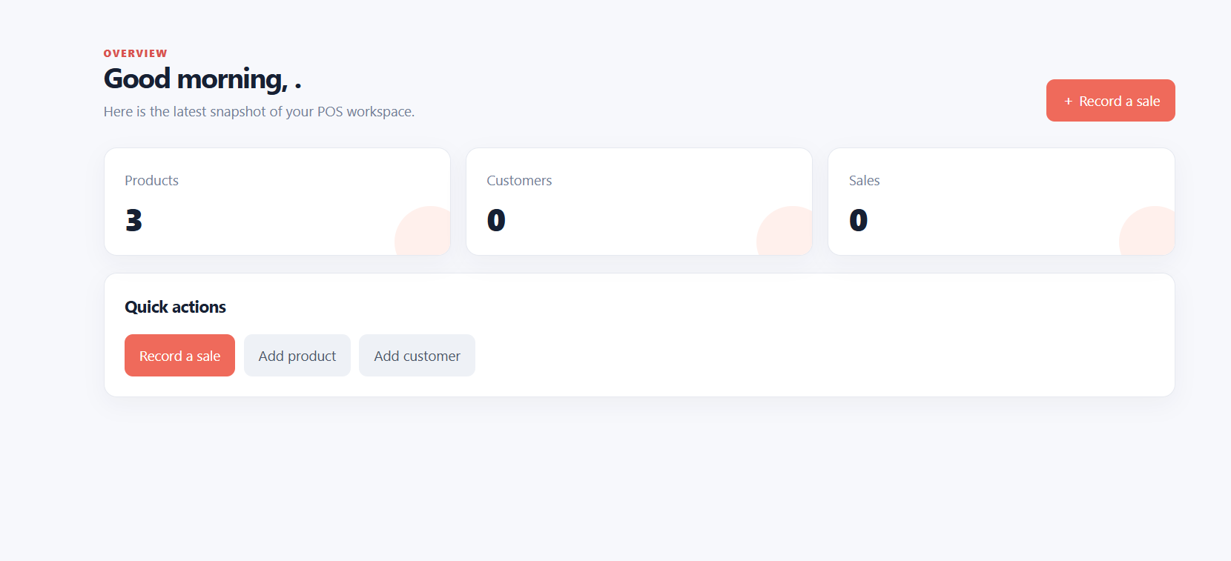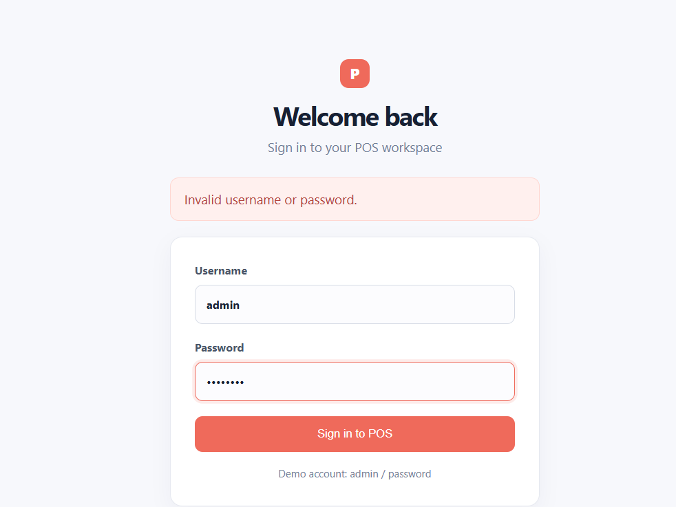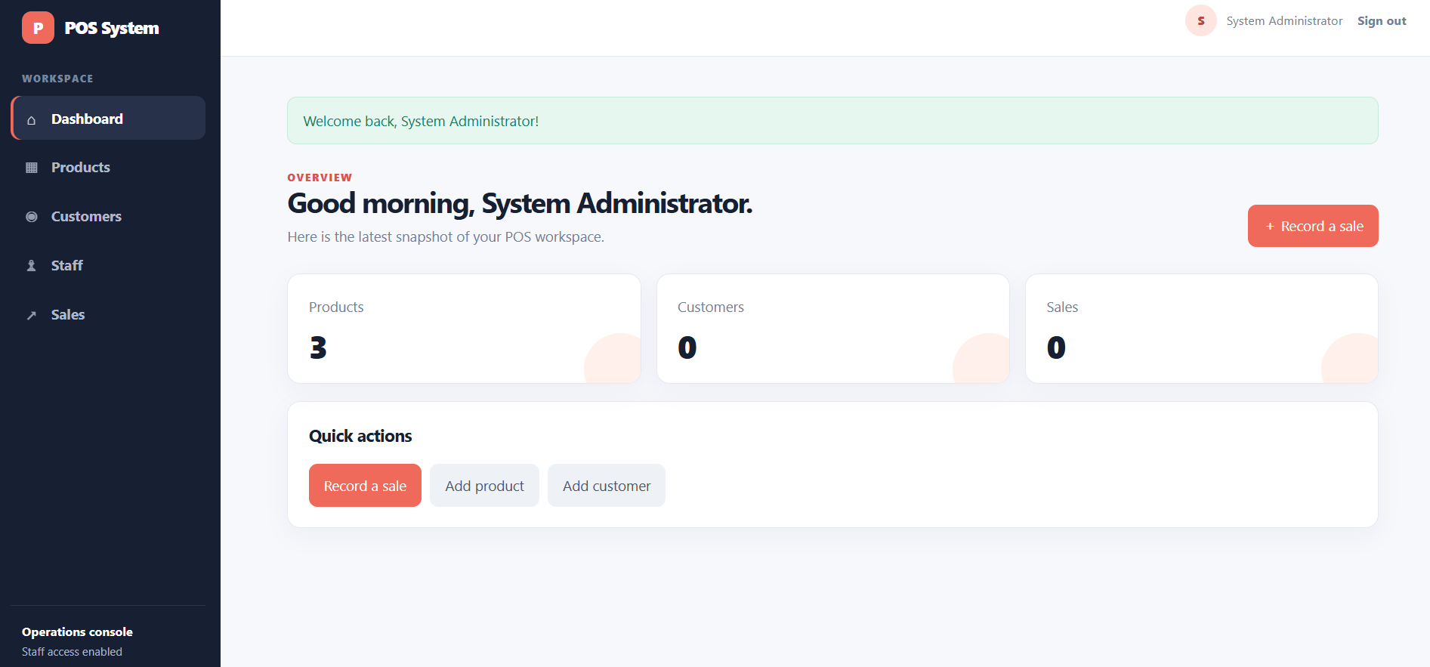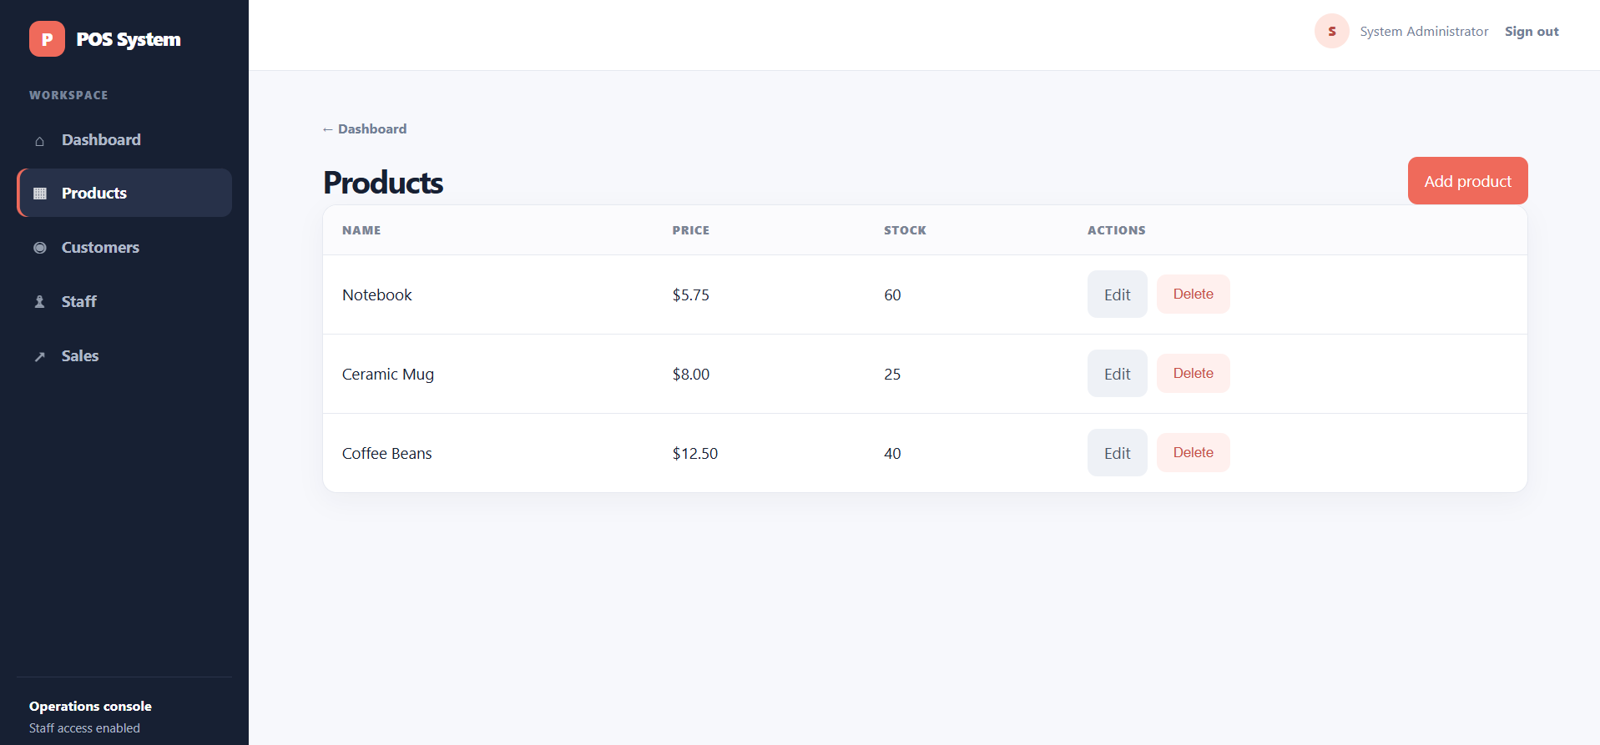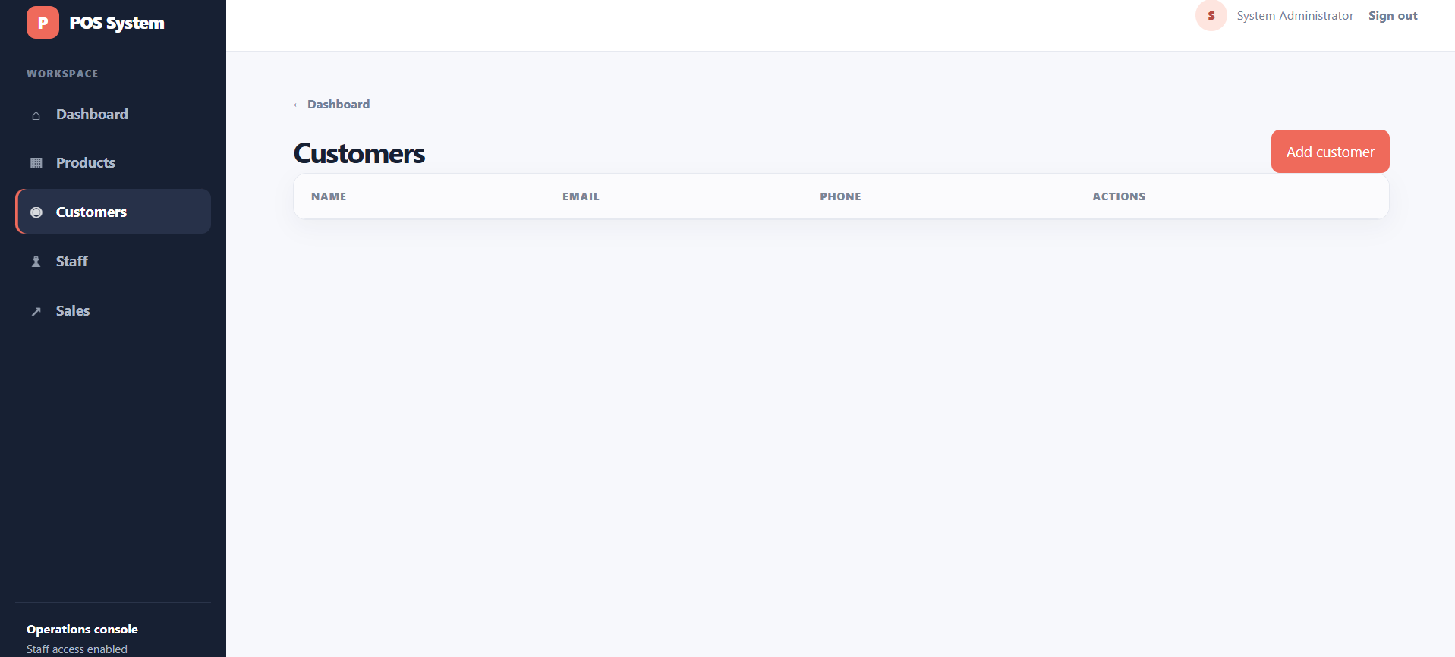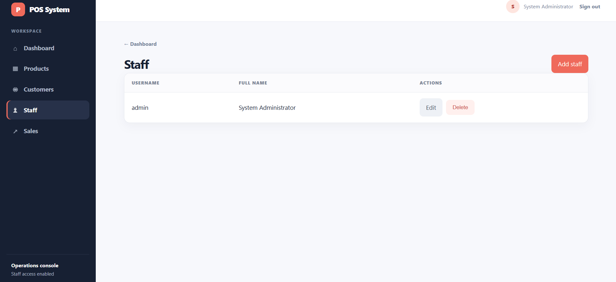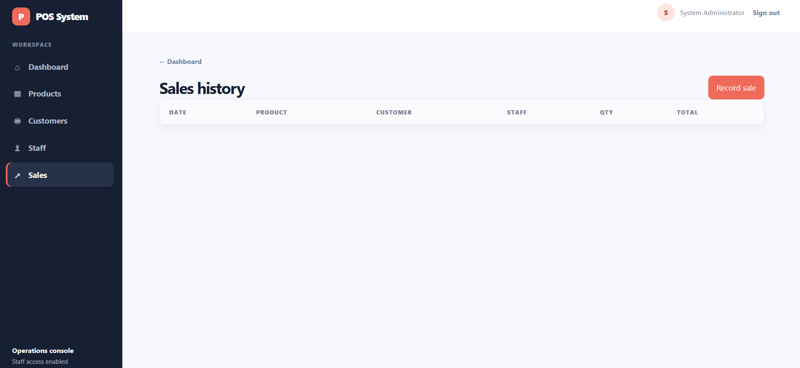
REFERENCES
- CodeIgniter User Guide. Sessions. https://codeigniter4.github.io/userguide/libraries/sessions.html
- CodeIgniter User Guide. Controller Filters. https://codeigniter4.github.io/userguide/incoming/filters.html

